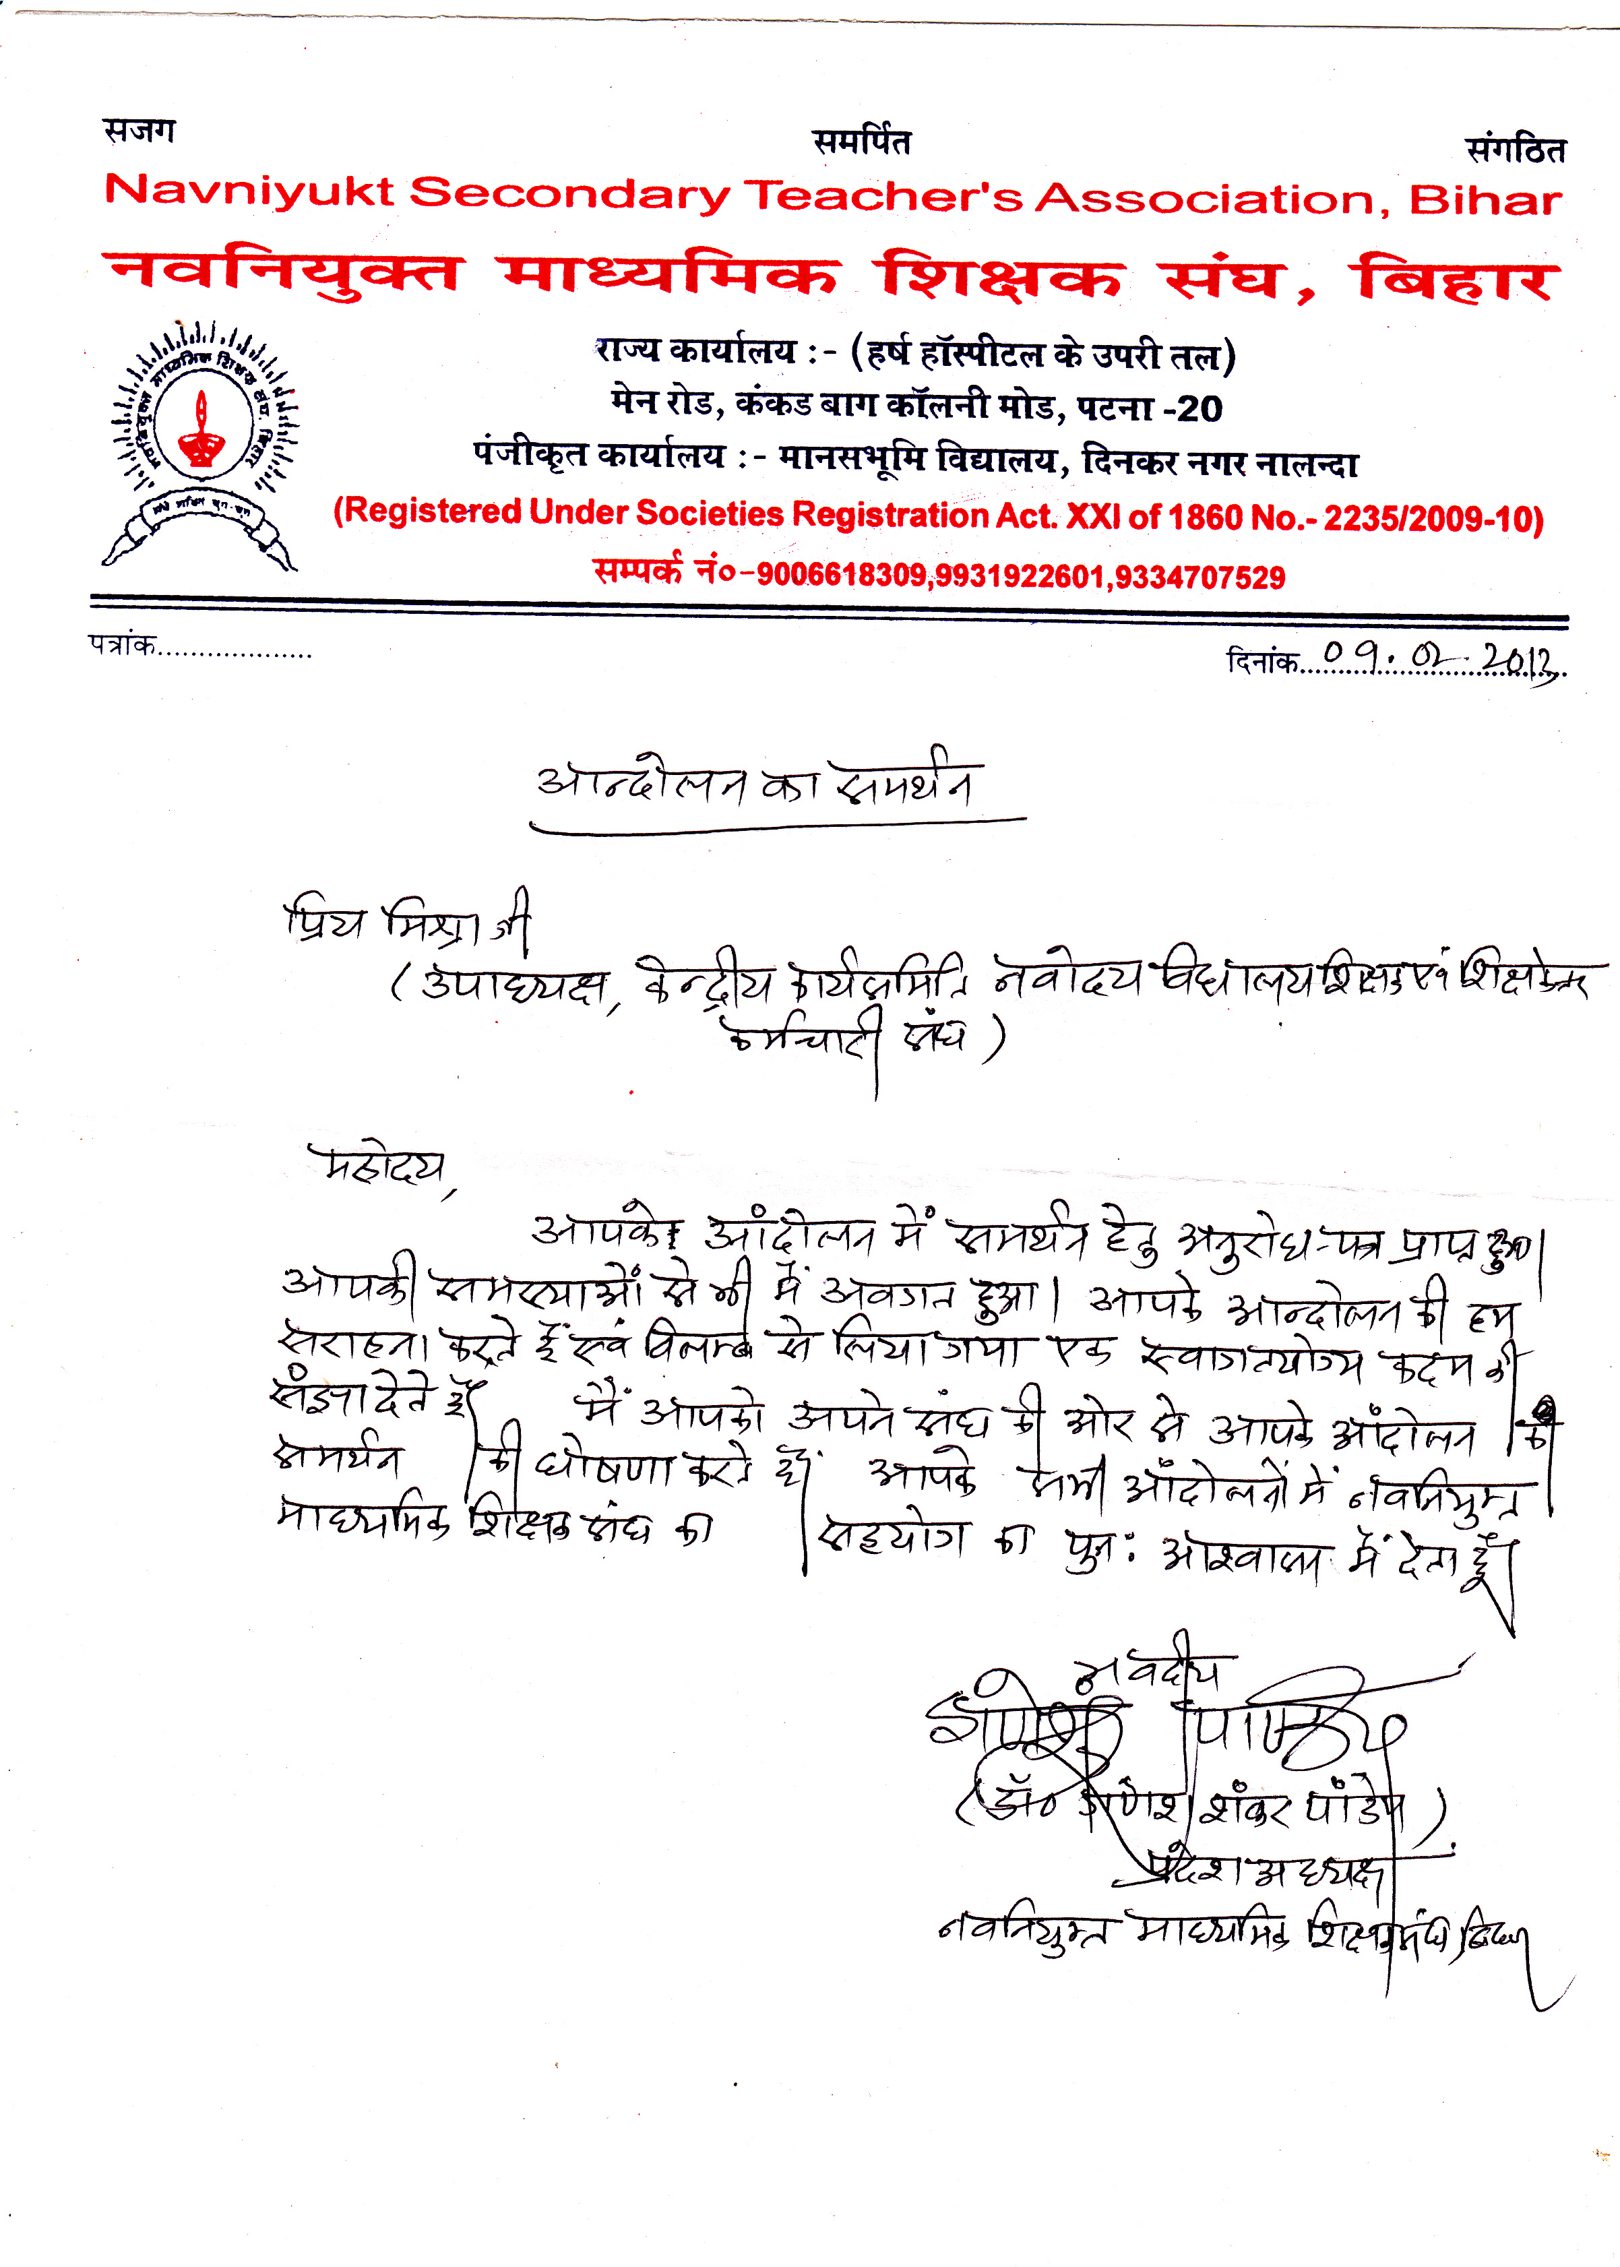
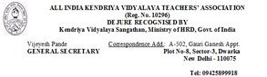
APPEAL
Dear friends,
You are aware that the teachers of Navodaya Vidyalaya Samiti are on indefinite strike in persuasion of their demands.
I, on behalf of all the teachers of Kendriya Vidyalaya Sangathan support the demands of the teachers of Navoday Vidyalaya Samiti and want to make an appeal to all my colleagues , Office bearers and members of AIKVTA to extend their full co operation to the teaching community of Navodaya Vidyalaya Samiti . It will not be out of place to request to all my learned colleagues of KVS to do nothing and to try to avoid sharing any responsibility, if any extended to them to shoulder, which may hamper the interest of the teachers of NVS and spirit of the agitation already initiated by the teachers of NVS.
Co operation of all the teachers of KVS will be highly appreciated.
With regards
Vijeyesh pande

